AJAX Device Configuration Guide – GCX-ONE
Overview:
GCX-ONE supports AJAX integration for centralized alarm reception. AJAX hubs containing NVRs, intrusion panels, and other alarm-triggering objects can be integrated with GCX-ONE for centralized alarm management.

Key Features of AJAX Integration:
1. Supported Device Types
  - AJAX Hub
  - AJAX NVR
2. Supported Functionality
  - Discovery
  - Alarm reception only
(No live streaming, playback, or PTZ features)
3. Alarm Transmission Protocol
  - SIA (Security Industry Association Protocol)

How AJAX Works in GCX-ONE:
AJAX Hub / AJAX NVR:
- The AJAX Hub acts as a container for multiple alarm objects such as intrusion panels, NVRs, and other sensors.
- In GCX-ONE, you can add either:
- AJAX Hub (AJAX manufactured cameras)
- AJAX NVR (Third party cameras)
- All alarms from Hub/NVR objects are received collectively under this device in GCX-ONE.

Steps to Configure AJAX Device in GCX-ONE:
1. Obtain Hub ID from AJAX Hub or Device ID for AJAX NVR
- Hub ID is required for adding AJAX Hub and Device ID for NVR.
- The Hub ID/Device ID must be collected from the AJAX client application (specific to the customer's Hub).
Important Note:
When entering the Hub ID or Device ID:
- GCX-ONE performs an existence check using the NXGEN API key.
- To allow verification, the customer must invite NXGEN to their AJAX Hub through the AJAX client application. Without this invitation, GCX-ONE cannot verify or link to the Hub/NVR.

2. Add AJAX Device in GCX-ONE

Step 1: Log in to GCX-ONE.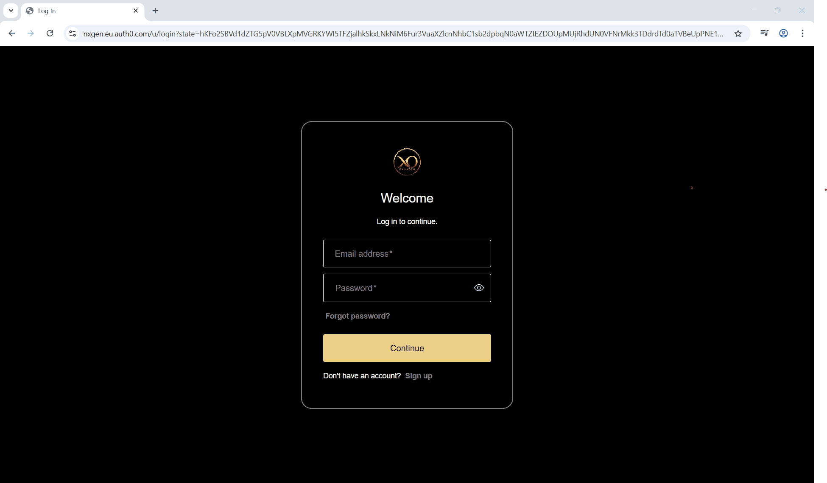
Step 2: Click on the Configuration menu.
Step 3: At the Service Provider level, click on Customers.
Step 4: Click the Add button.
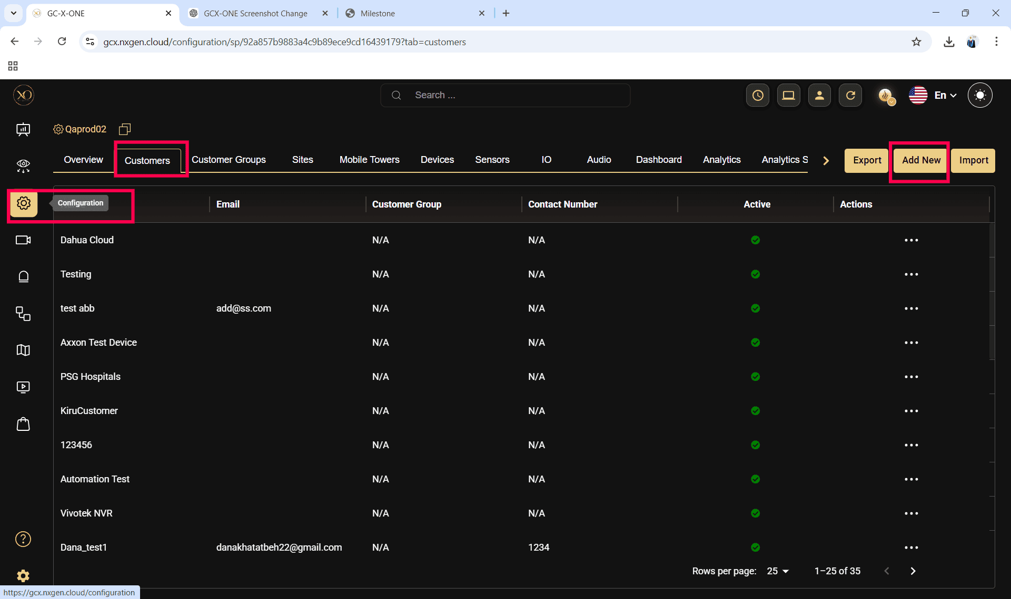

Step 5: Enter the required fields and click Save.
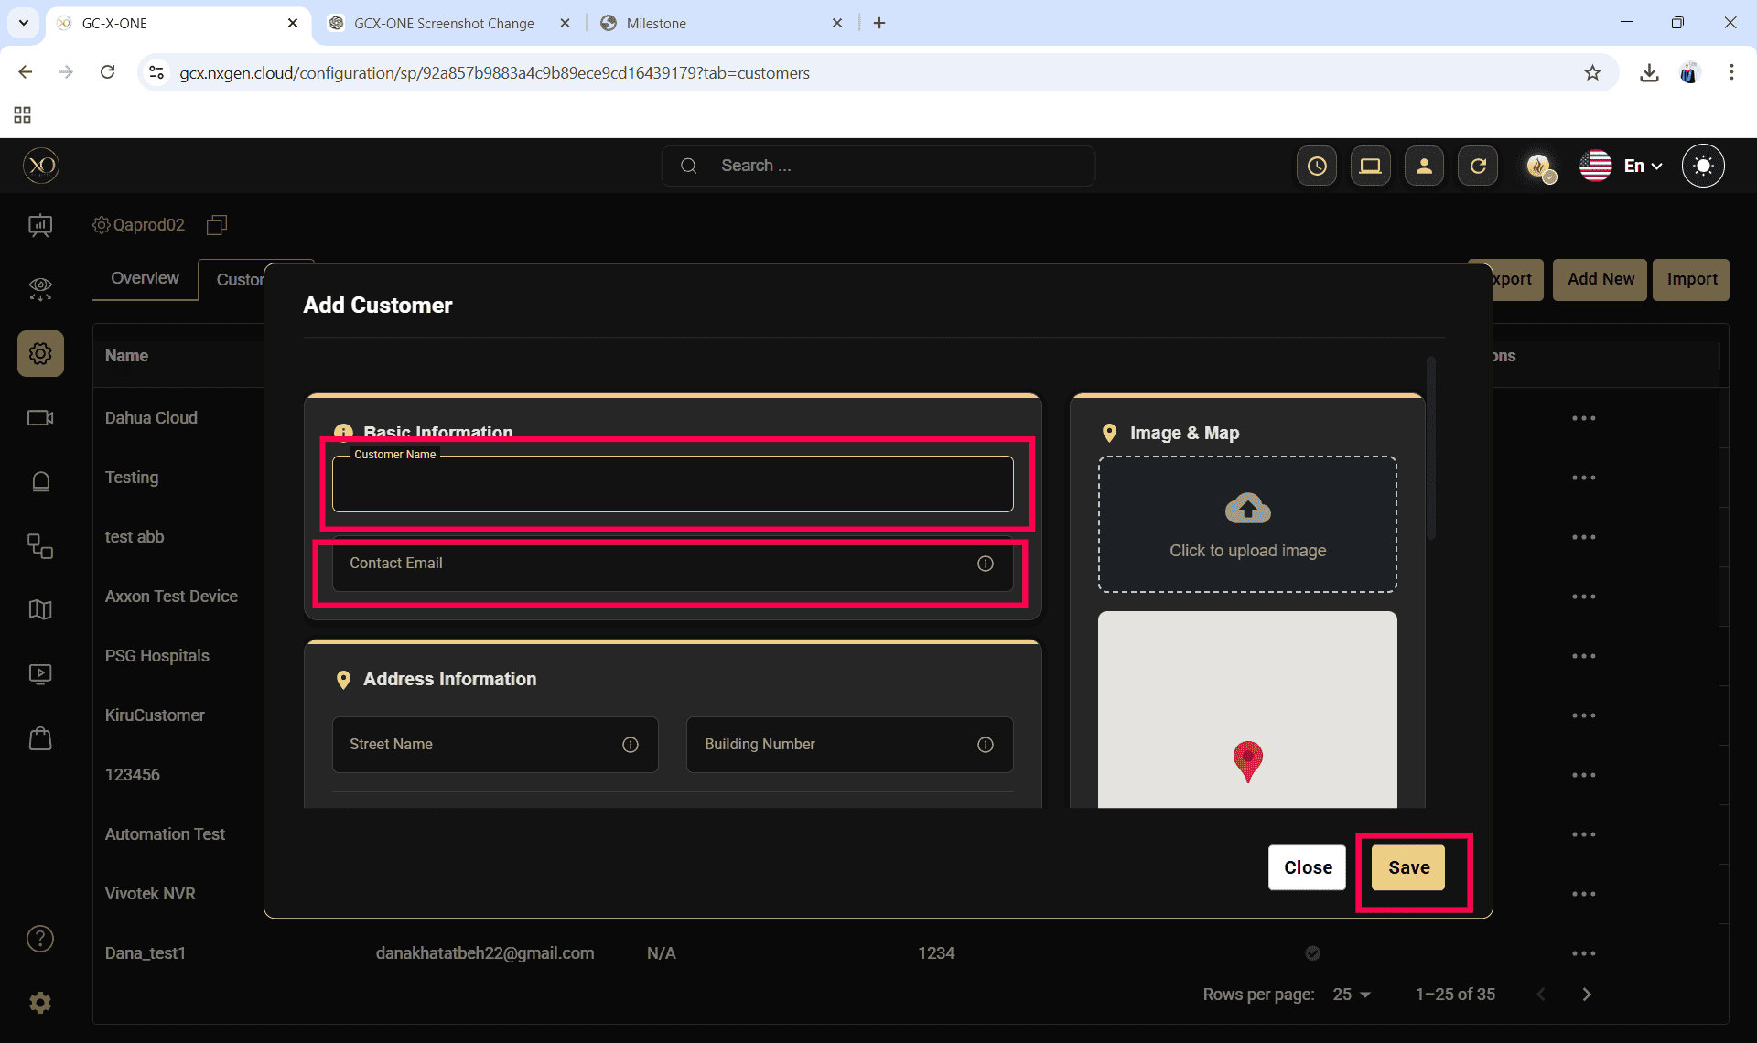
Step 6: Select the newly created customer.
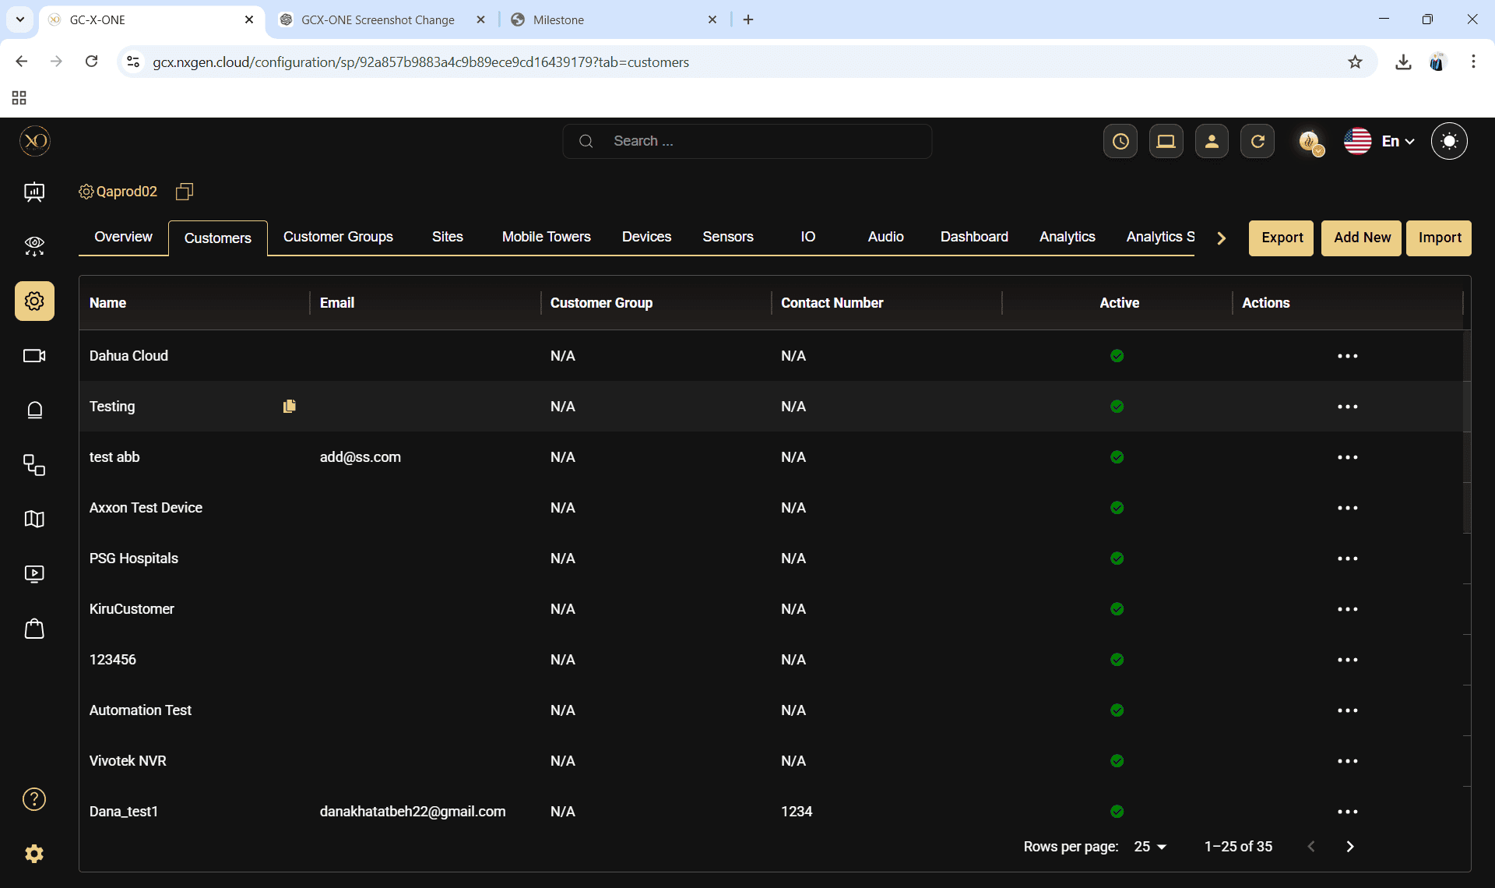

Step 7: Navigate to the Sites tab.
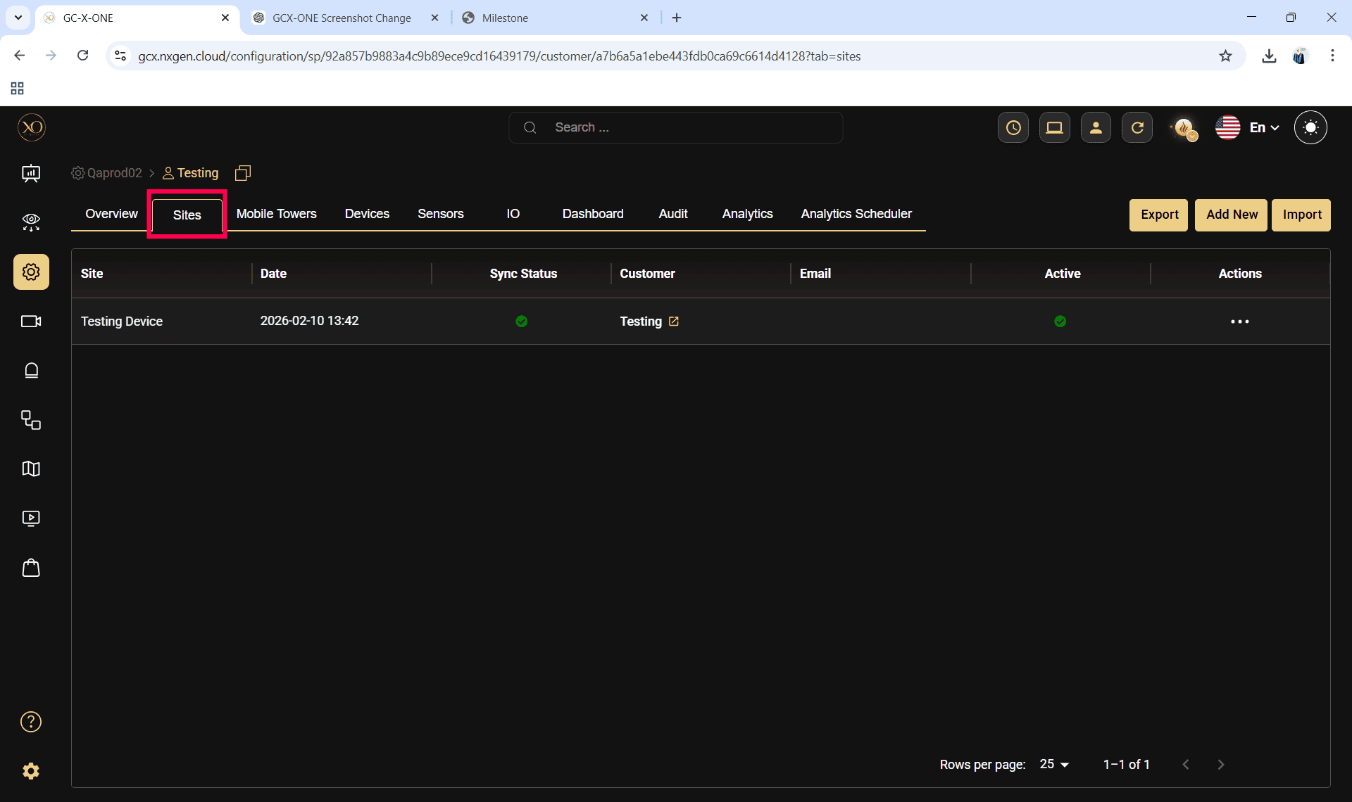
Step 8: Click the Add button.
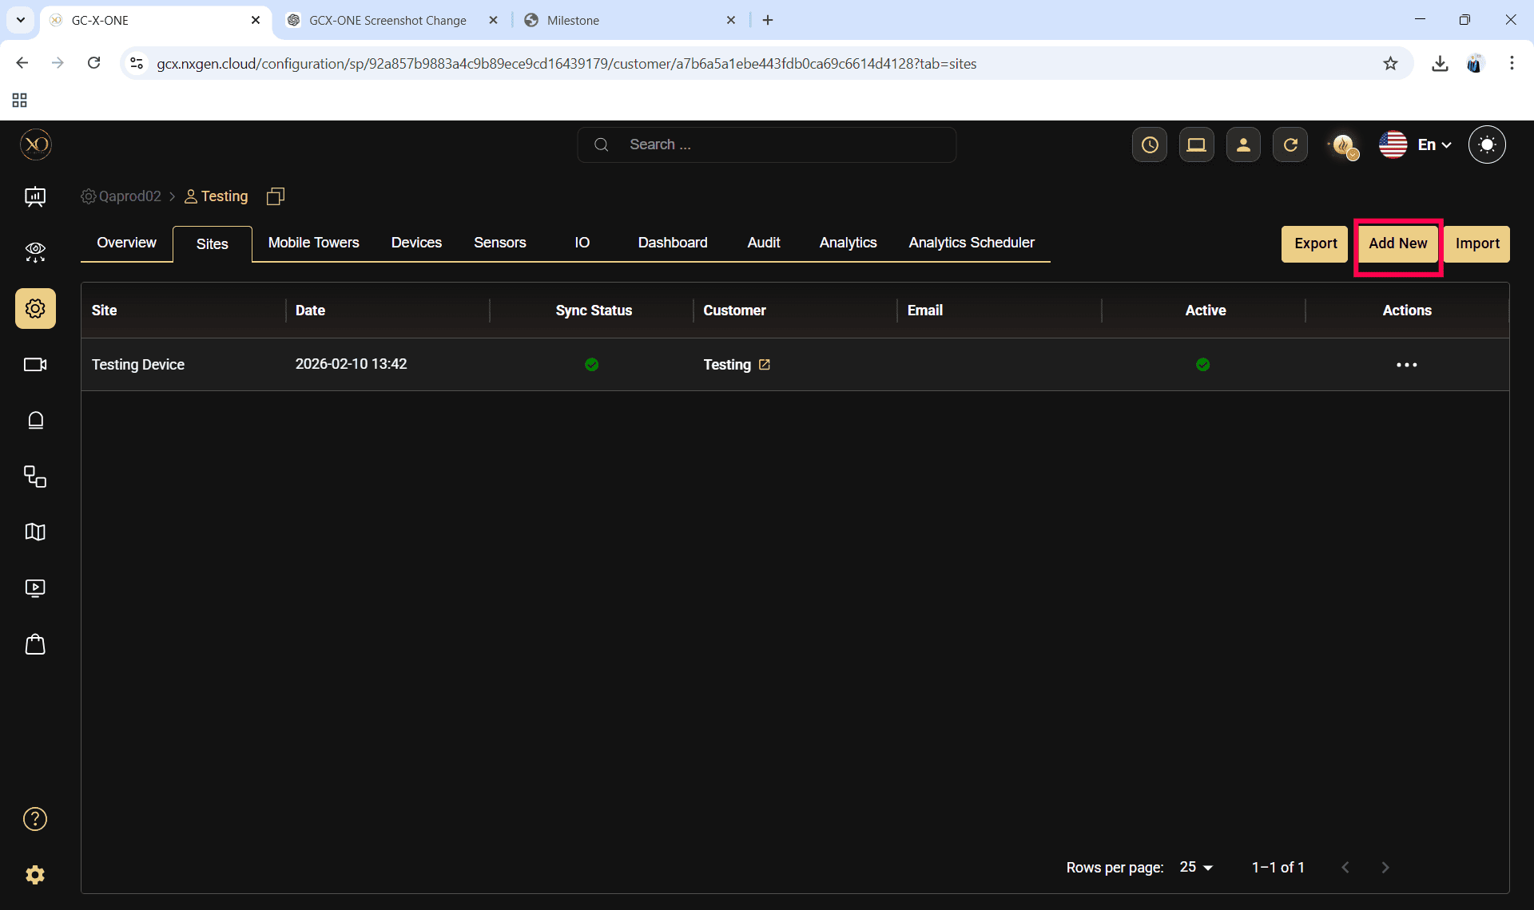

Step 9: Enter the required fields and click Save.
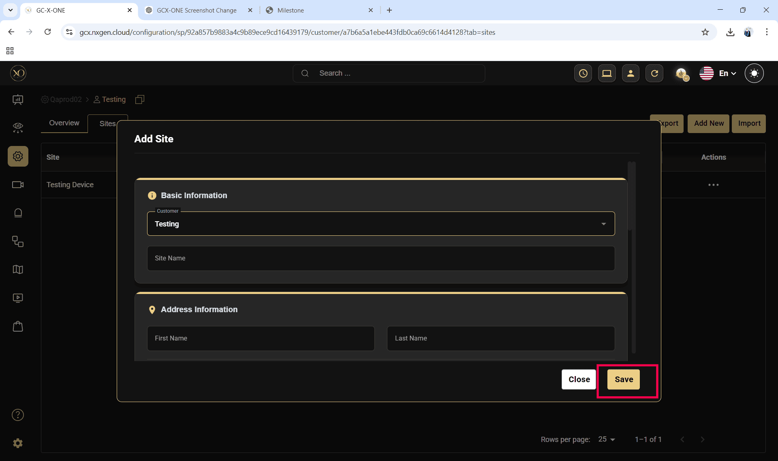

Step 10: Select the newly created site.
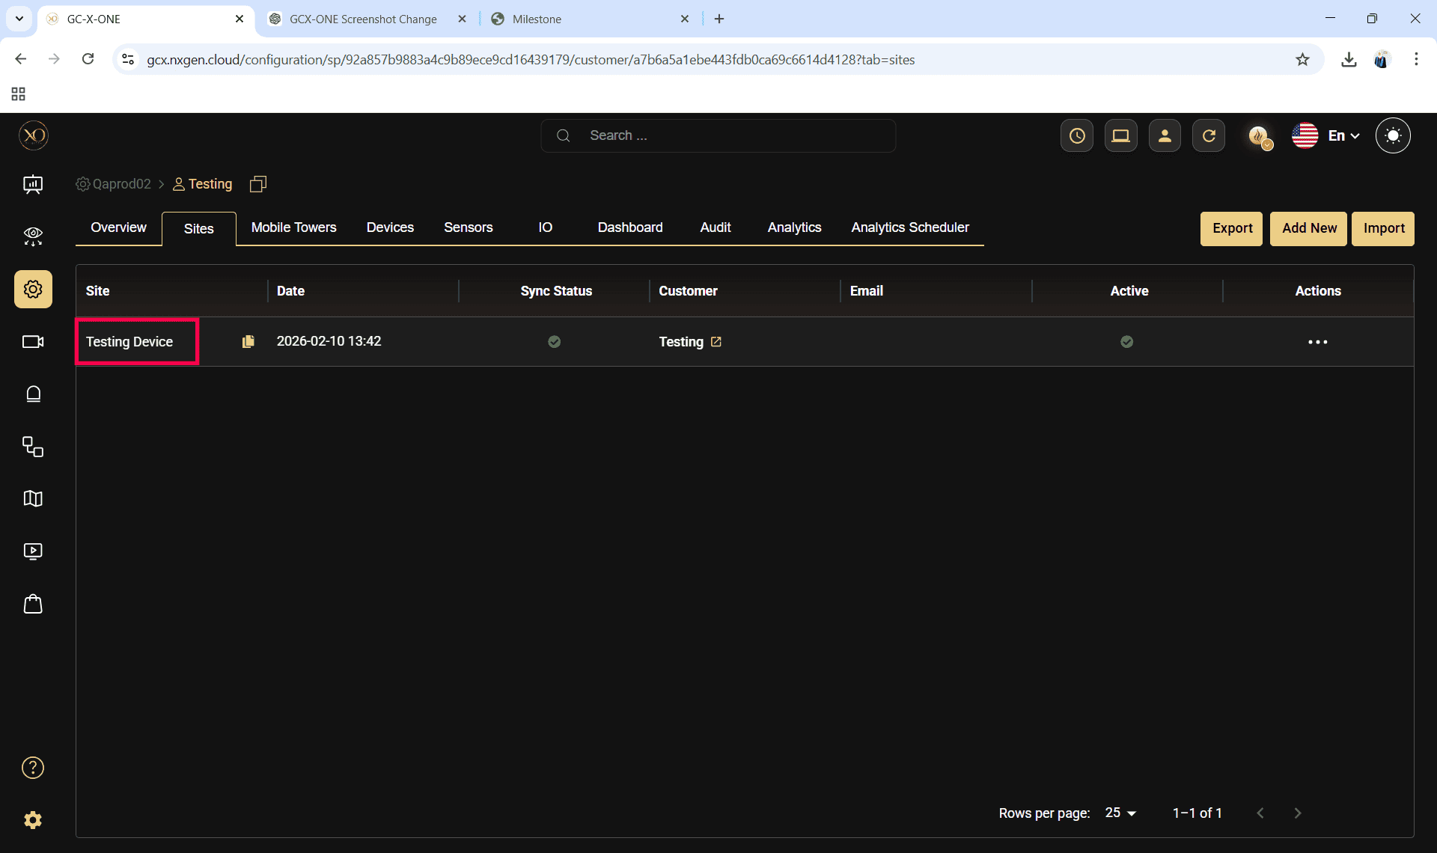

Step 11: Navigate to the Devices tab.
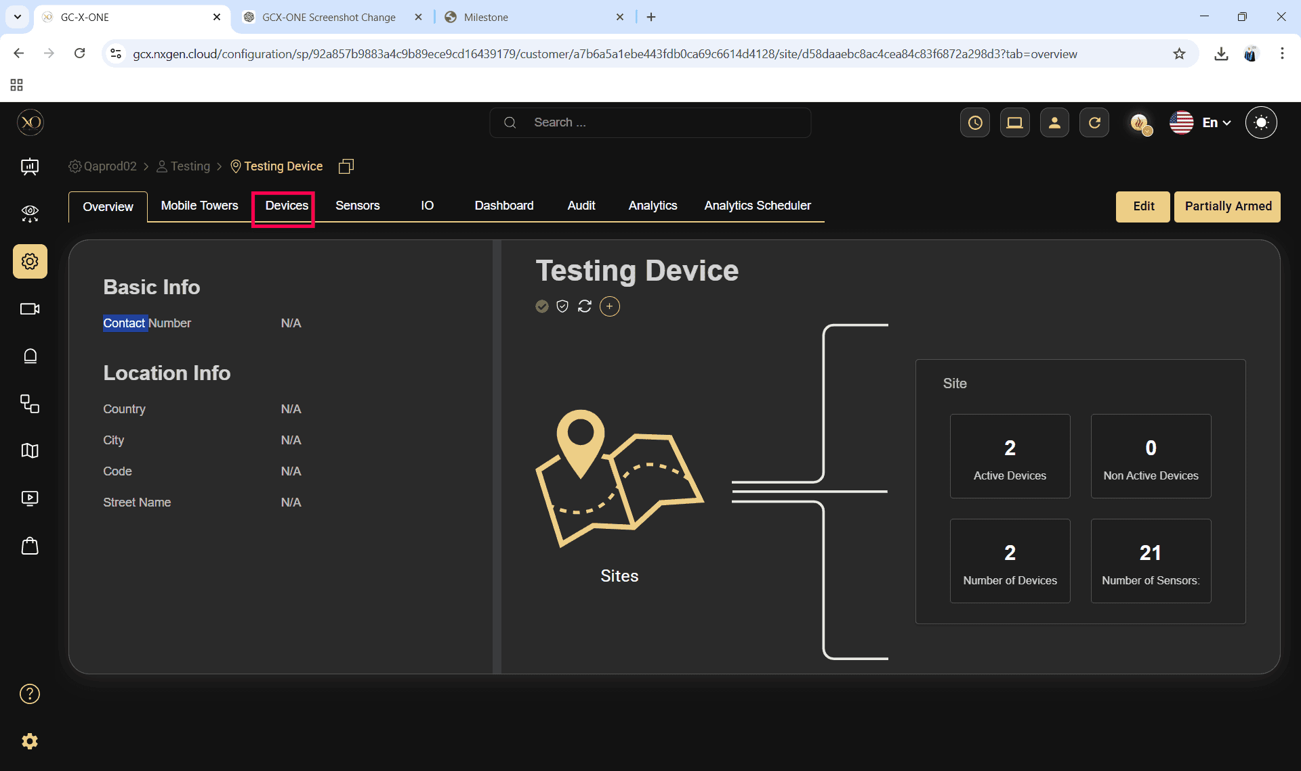
Step 12: Click the Add button.
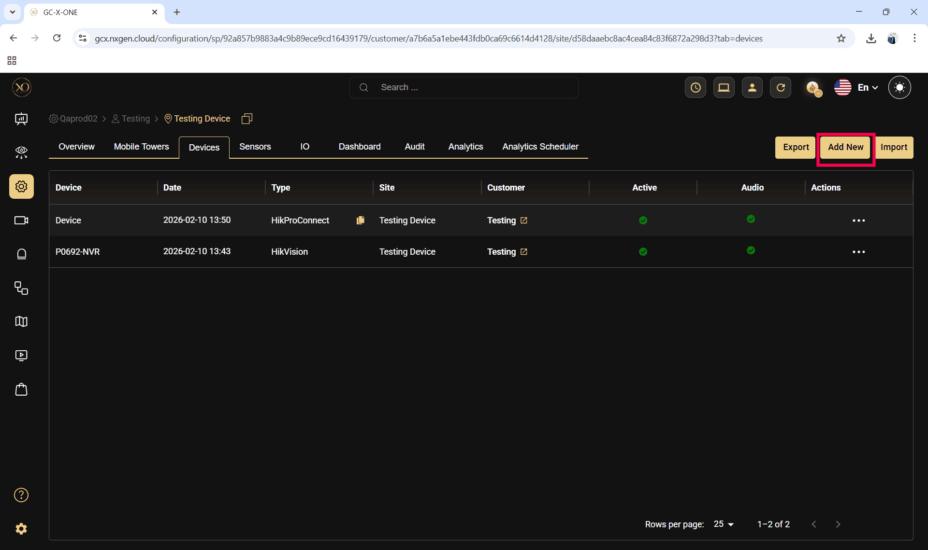

Step 13: The Add Device dialog will be displayed.
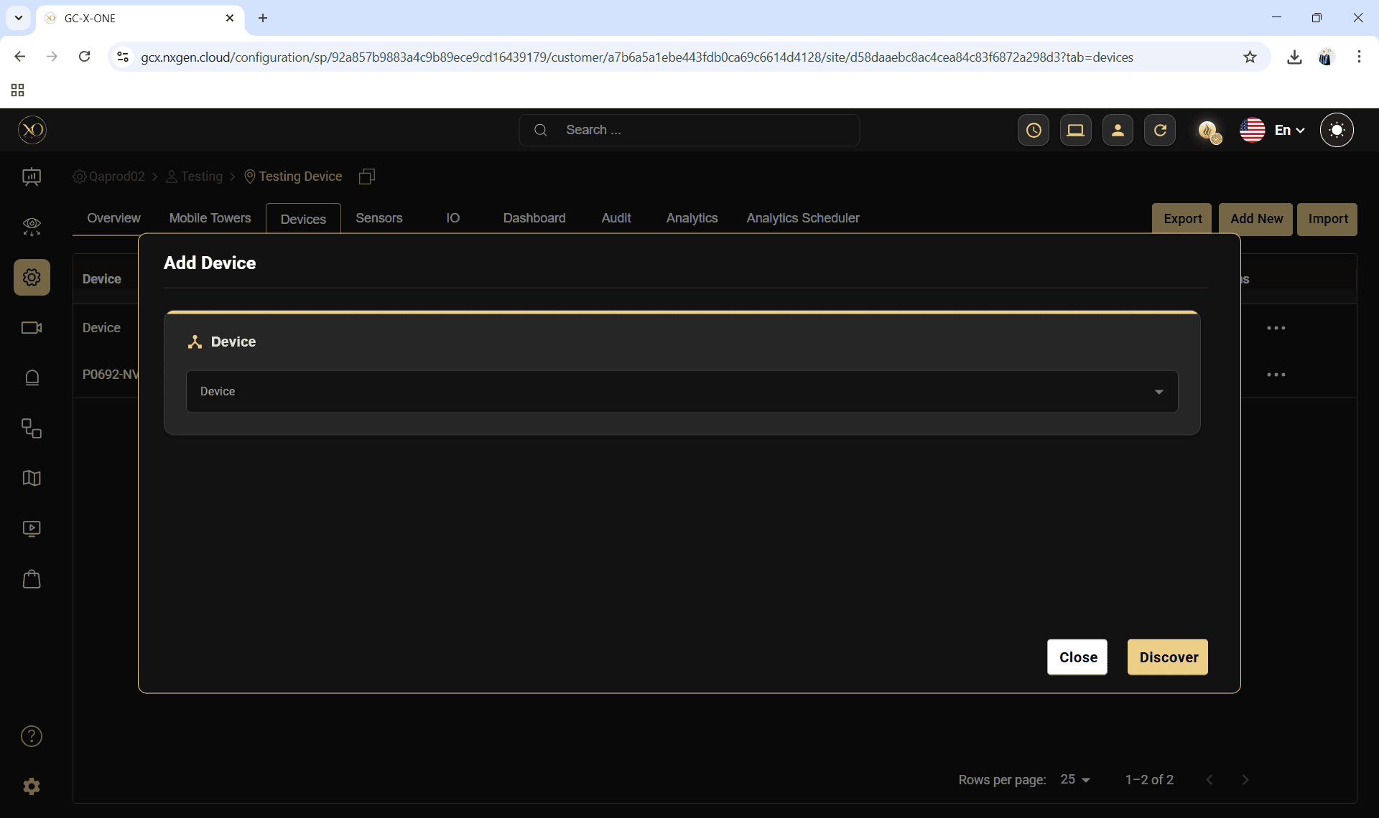

Step 14: In the dialog, open the Device dropdown and select AJAX Hub or AJAX NVR.

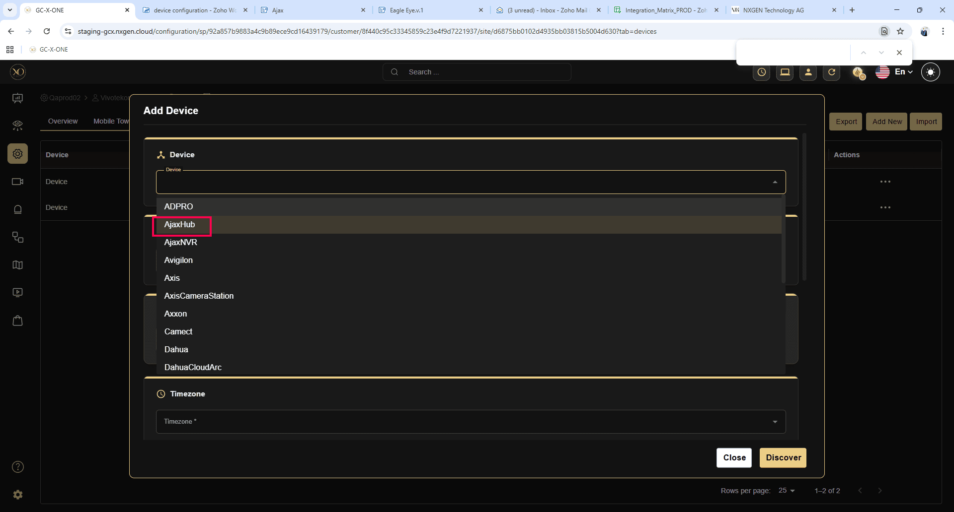

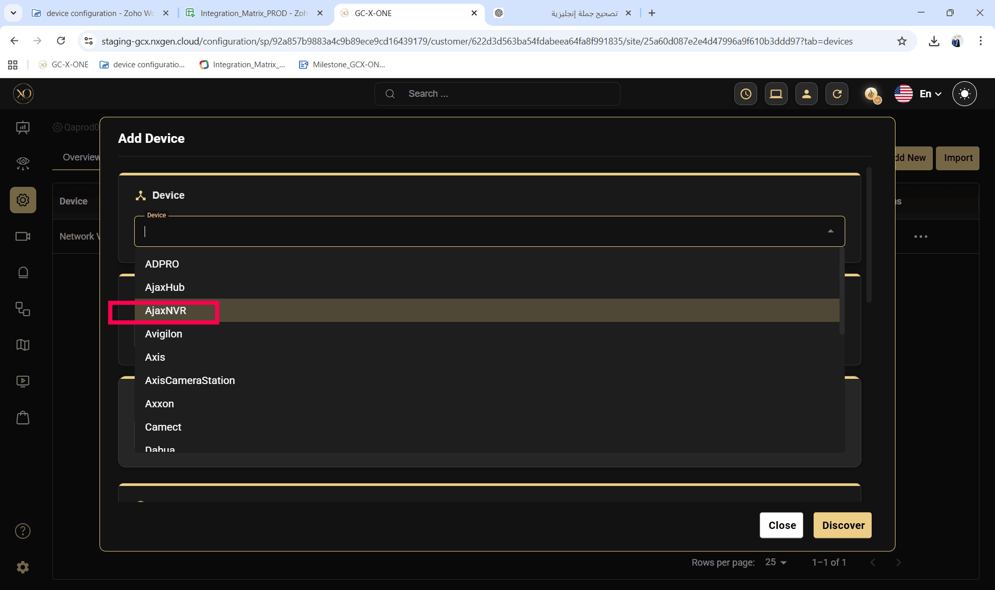

Step 15: Enter all required fields:

Name

Time Zone
- Hub ID (for AJAX hub)
- Device ID (for AJAX NVR)

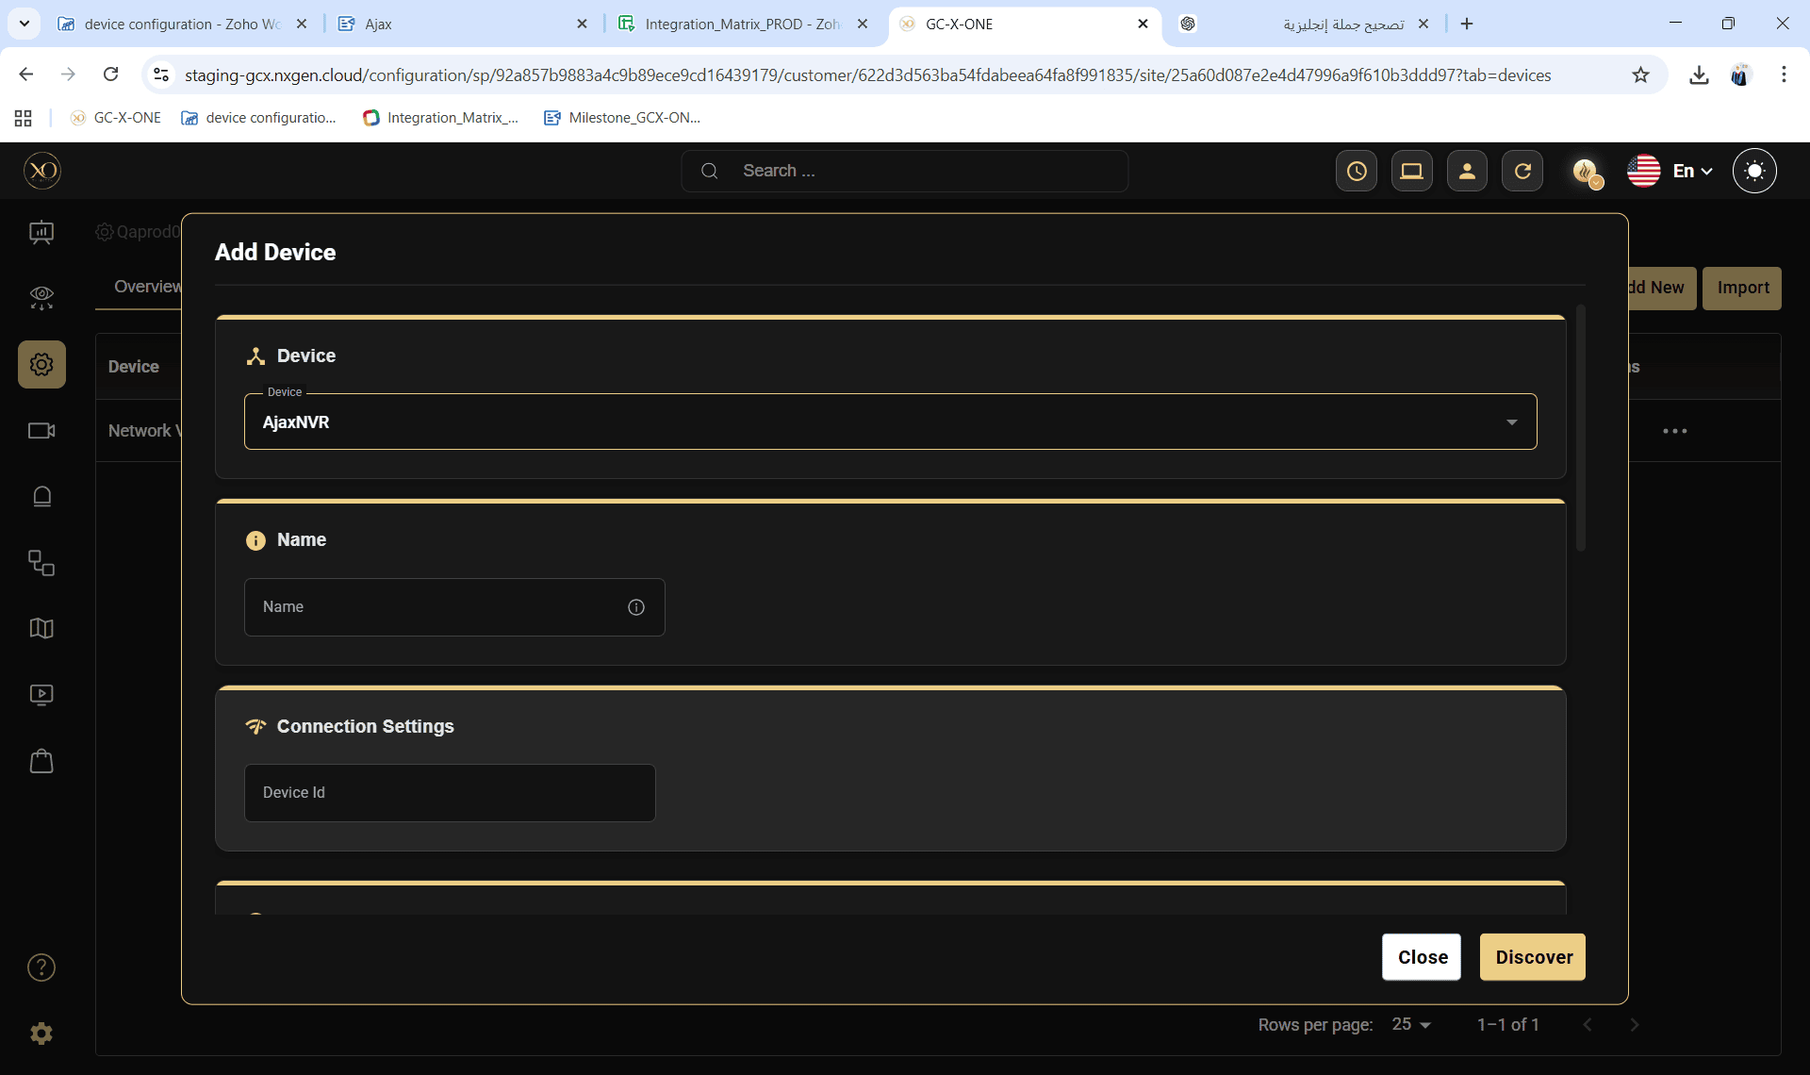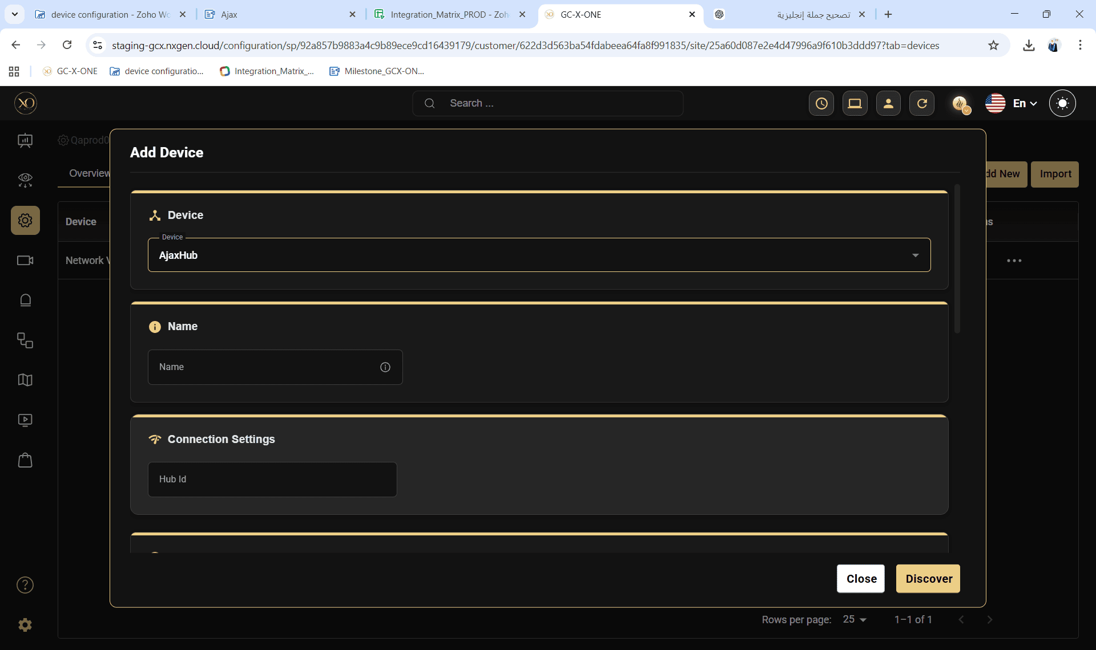

Step 16: Click Discover.
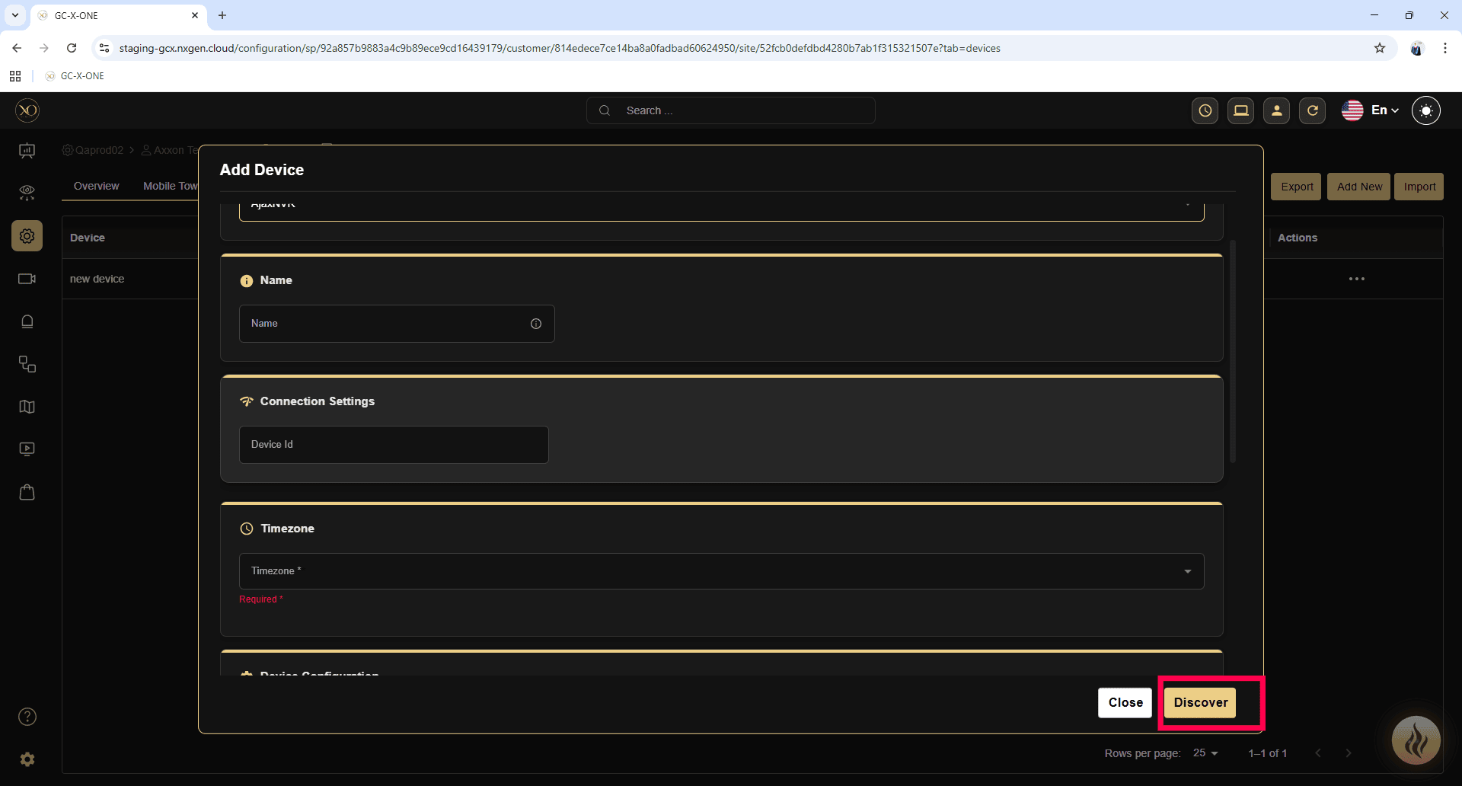
- The platform will connect to and verify the Hub/NVR.
- On success:
- For Hub → All devices associated with the Hub will be automatically fetched and displayed in a list.
- For NVR → All cameras associated with the NVR will be automatically fetched and displayed in a list.

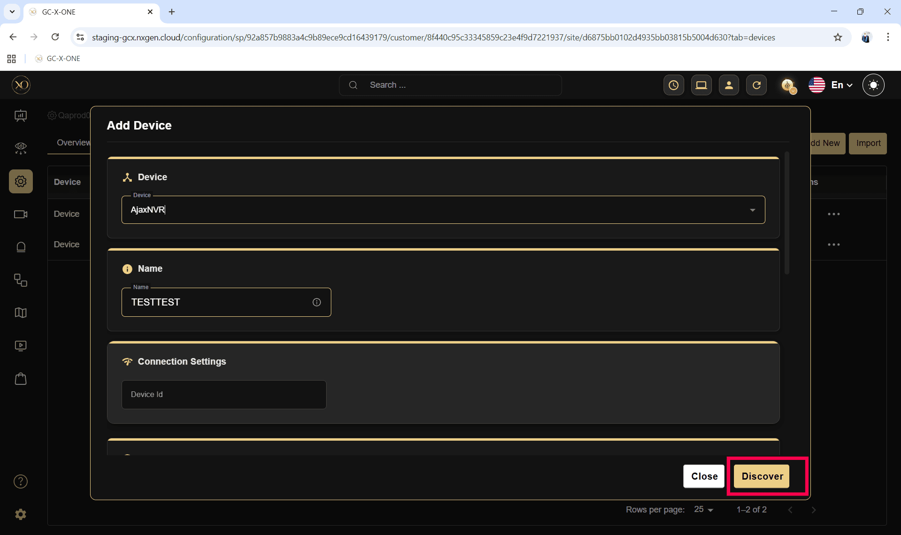

- Review the discovered devices or cameras.
- Confirm the details.
Step 17: Once the device is successfully discovered, click Save.

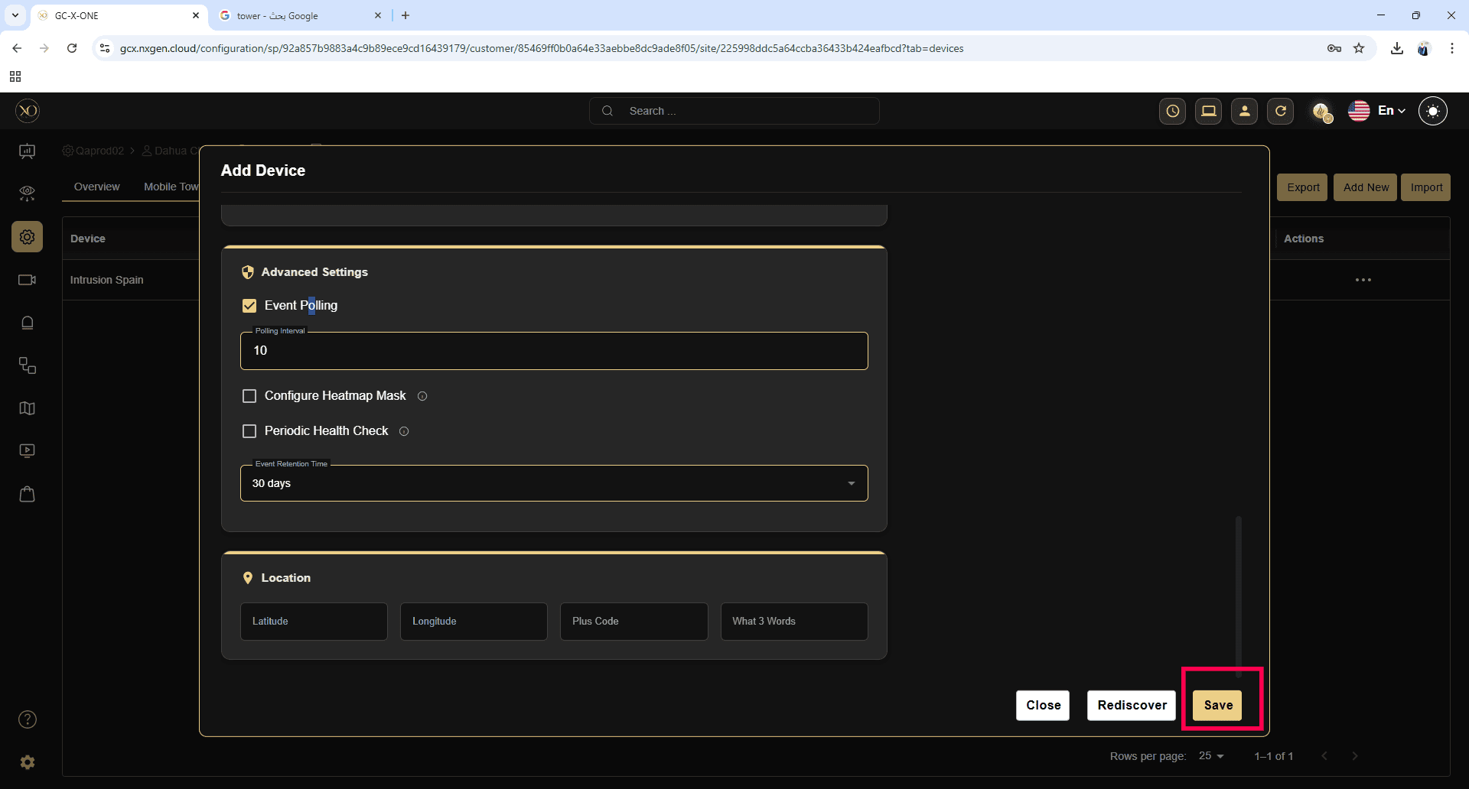

3. Configure SIA Alarm Receiver (AJAX Client):
- After adding the device:
- Locate your newly registered AJAX device in the device list.
- Click the View button beside the device.
- On the device overview page, The required information will be displayed as shown in the screen below:
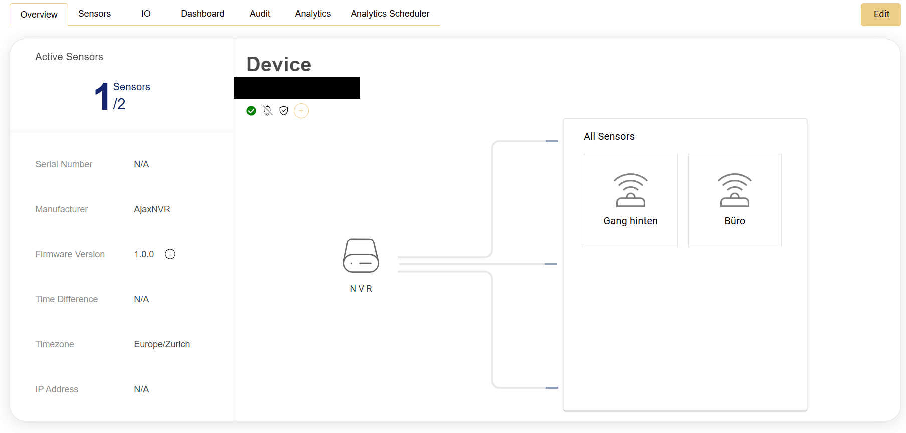

4. Steps in AJAX Client:
Receiver IP/PORT: Configure at Company Level in the AJAX client.
Encryption Key: Configure at Company Level in the AJAX client.
Account Number: Configure at Object Level in the AJAX client (for the Hub or relevant alarm object).
Refer to the following guide for detailed receiver configuration instructions:
AJAX Integration Guide

Limitations

